



eProject Document
ASKME-MOBILE
Group 5
Members | Mac Duy Thanh – Student1253302  Nguyen HuyHoang – Student1240567  Nguyen Thi Binh – Student1247034  Lai Thi Hanh – Student1247028
Instructor | Nguyen Van Luan
Batch | C1908I1
Semester | I

 Implementation date 07/05/2020-26/05/2020 

Hardware and Software Requirements

Hardware Requirements
- A minimum computer system that will help you access all the tools in the
courses is a Pentium 166 or better
- 64 Megabytes of RAM or better

Software Requirements
- Notepad/HTML editor
- Dreamweaver
- IE 5.0/ Netscape 6.0
+ Computer should have internet to execute send e-mail to member or customer.

Install Application “Xampp”.

Download Xampp
- Step 1 : Download Xampp.
Link Download: https://taimienphi.vn/download-xampp-17727
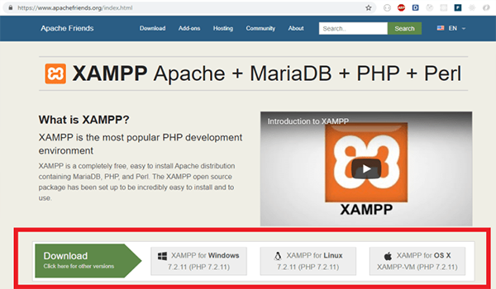

Step 2 : Click the file with the extension .exe on the download file
Step 3 : After downloading Xampp to your computer, open the folder containing this file and double-click the file icon to start the installation. You will asked to select an installation language, here I choose the language is English and click Ok.

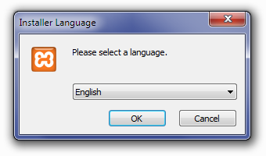

- Step 4 : Click on Next
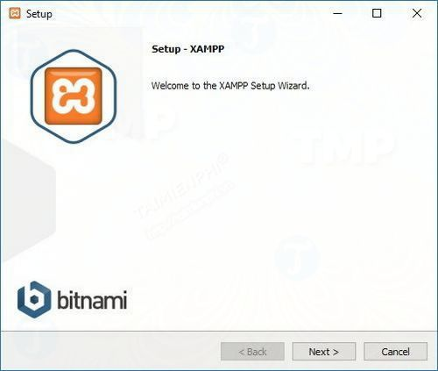

Step 5 : Xampp provides a variety of components that users can install such as MySql, PhpMyAdmin, Php,..So beston the setup window, you keep the default settings and then click next.
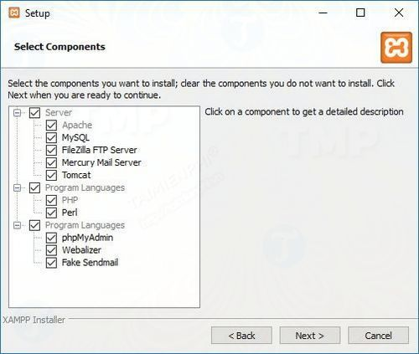

- Step 6 : Uncheck the box next to Learn More About Bitnami for Xampp and click Next
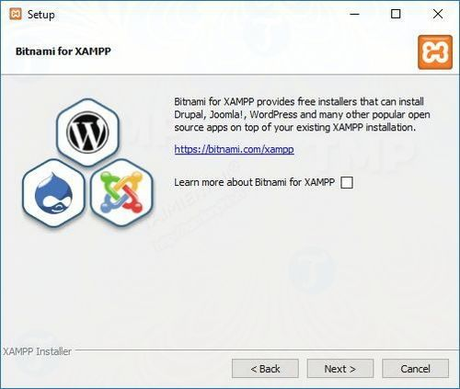
- Step 7 : Next, can you choose a directory to install the software or keep the default installation location and then click Next to begin the installation process
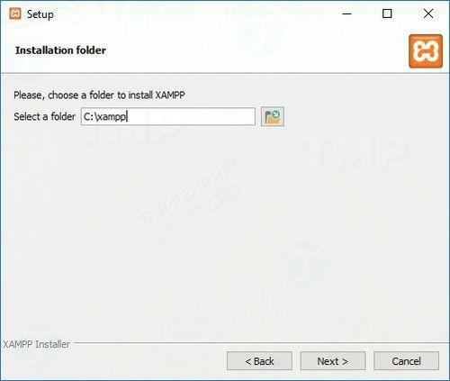
- Step 8 : During the installation process Windows will ask the user to allow specific services to communicate through a firewall.Click allow access to continue.
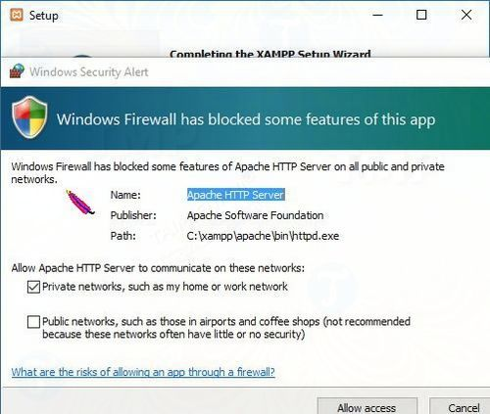
- Step 9 : Click Finish to complete the installation process and you can start using the Xampp Control Panel.
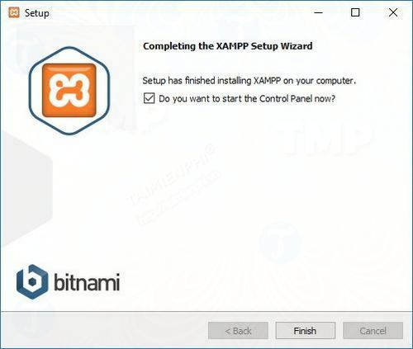

- Step 10: : Select the language used and then click Save to complete the process and open Xampp Control Panel.
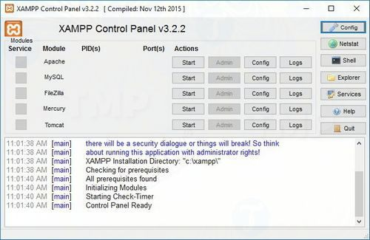

Download Sublime Text 3
- Step 1: Download Sublime Text 3 to your device:
Link download: http://www.sublimetext.com/3
- Step 2: After completing the download. We proceed to the installation. Click Next to continue the installation process.
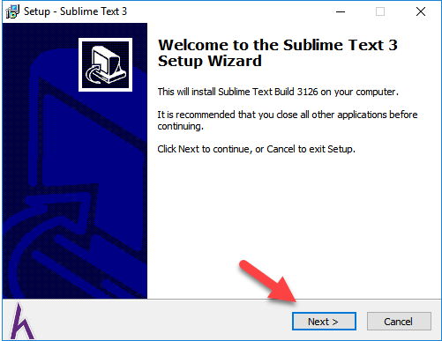
- Step 3: You van customize the link in the Browse section . I encourage you to choose Next
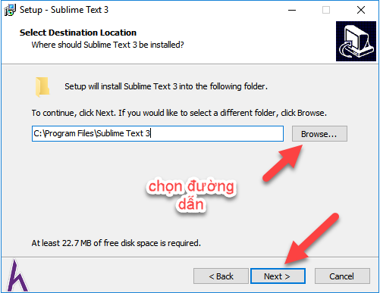
- Step 4: Click Next
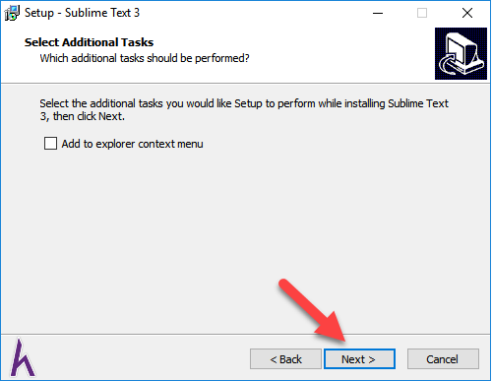
- Step 5: Click Install
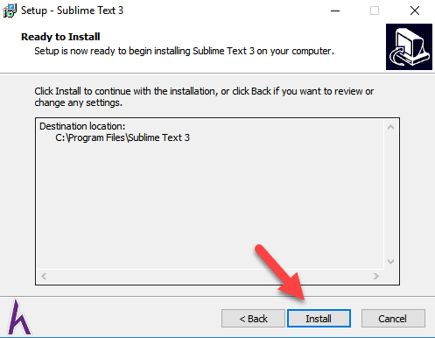
- Step 6: Click Finish to finish the installation process
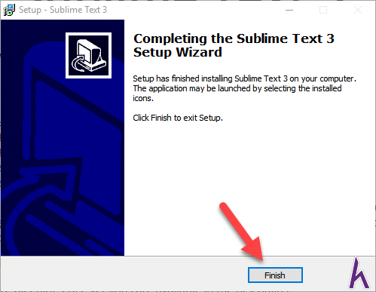

THE END

